# JS Advanced: Exam 30.08.2018

# Problem 1. Holiday Destinations (Simple DOM Interaction)

You are given the following **HTML code**:

|  |
| --- |
| holidayDestinations.html |
| <!DOCTYPE html>  <html lang="en">  <head>  <meta charset="UTF-8">  <title>Holiday Destinations</title>  <style>  #wrapper { margin: auto; width: 50%; border: 2px solid rgb(138, 43, 226);  font-family: Verdana, Geneva, Tahoma, sans-serif;  background-color: rgb(247, 247, 247); color: rgb(138, 43, 226); }  #input, #summaryBox { margin: auto; width: 90%; }  .custom-select, .button {font-family: Verdana, Geneva, Tahoma, sans-serif;}  .button { cursor: pointer; background-color: white; }  .summary { width: 40px; }  .inputData { width: 70px; }  h1, h3 { text-align: center; }  table { margin: 0 auto; width: 75%; }  table, th, td { border: 1px solid rgb(138, 43, 226); }  input, .custom-select, .button { border: 1px solid rgb(138, 43, 226);  color: rgb(138, 43, 226); padding: 5px 15px; }  </style>  <script src="https://code.jquery.com/jquery-3.3.1.min.js"></script>  <script src="solution.js"></script>  </head>  <body>  <div id="wrapper">  <h1>Holiday Destinations</h1>  <div id="input">  <label>City:</label> <input class="inputData" type="text">  <label>Country:</label> <input class="inputData" type="text">  <label>Season:</label>  <select id="seasons" class="custom-select">  <option value="summer">Summer</option>  <option value="autumn">Autumn</option>  <option value="winter">Winter</option>  <option value="spring">Spring</option>  </select>  <button class="button" onclick="addDestination()">Add Destination</button>  </div> <br>  <table id="destinations">  <thead>  <tr>  <th>Destination</th>  <th>Season</th>  </tr>  </thead>  <tbody id="destinationsList"></tbody>  </table>  <br>  <h3>Destinations for 2018:</h3>  <div id="summaryBox">  <label>Summer:</label><input class="summary" id="summer" type="number" value="0" readonly>  <label>Autumn:</label><input class="summary" id="autumn" type="number" value="0" readonly>  <label>Winter:</label><input class="summary" id="winter" type="number" value="0" readonly>  <label>Spring:</label><input class="summary" id="spring" type="number" value="0" readonly>  </div>  <br>  </div>  </body>  </html> |

### Your Task

You are hired by a travel agency to help them with the digitalization of their business. Here they need you to finish the implementation of this user interface, which allows them to keep track of all of the destinations they offer holidays to.

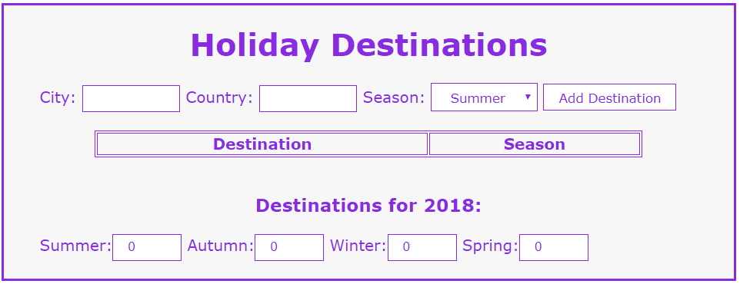

**Write the missing JavaScript function** addDestination **()** to make the **[Add Destination]** button work as expected – when clicked **adds** the new destination to the table with destinations and **updates** the destinations per season section at the bottom. The **[Add]** button should:

* **Append** the **text** received from the **input boxes** and the **text** of the **selected season** from the **dropdown** as a **new** **row at the end** of the **table’s body**. The **destination** name should bein the following format**:**

“{city}, {country}”

* **Update** the **number of destinations per season** in the“summaryBox”section.
* **Clear** the **input boxes** after the **destination’s information** is **submitted**.
* **Do nothing** if **either** of **text boxes** is **empty**.

### Submission

Submit only your addDestinationfunction.

**Scroll down** to see the examples.

### Examples

